Emails to Book Speaking Engagements

If you want to book webinars in organizations you want to do the following:

1. Locate organizations where you might speak locally. Search online with Google for professional organizations and then search the website to see if they have a regular speaking/ webinar program with people like you.

2. Then find the contact person responsible for booking speakers. You can send simple emails or make inquiry calls to find out. “Who is the person responsible in your organization for booking speakers/webinar presenters for your meetings (or how do I apply to give a talk/webinar to your organization)?

3. Then once you find out, write an email something like the one below. Yeah, a great cartoon can really work for this. There is humor here, a demonstration that you know the audience and a lot of credibility. It makes you look both knowledgeable and fun. You can find cartoons by doing a Google search on “Your Topic + Cartoon” You might be amazed what you’ll find. (The cartoon is optional, but it can be a great attention-getter. I’ve attached some samples below.)

4. If and when they get back to you, you can send a more in-depth speaker’s kit with a write up of your talk or talks, a bio page and testimonial quotes. Look up “Speaker’s kit” on Google for examples and graphic layouts. Then find someone to help you put it together. Also, these days; it’s great to have a video of you speaking. Once way to do it is to record your presentation on Zoom.

5. Make sure to do a follow-up call to answer any questions and make that personal connection. And have fun on the call, instead of being a boring dullard. Then do whatever you need to do to book a speaking gig with the organization.

Sometimes they’ll have to run this past a committee so high-pressure tactics won’t work. Just be very helpful and talk about all the benefits of your talk.

I have booked a LOT of talks with this simple approach. It works best for local organizations. For bigger conferences, you’ll have to jump through more hoops. But it can really pay off big time if you get in front of the right audience.

Here are some cartoon examples. You are free to use these! I found all of these on Google in just a few minutes.

Decision-making  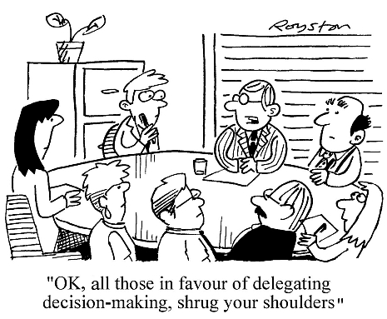 | Leadership  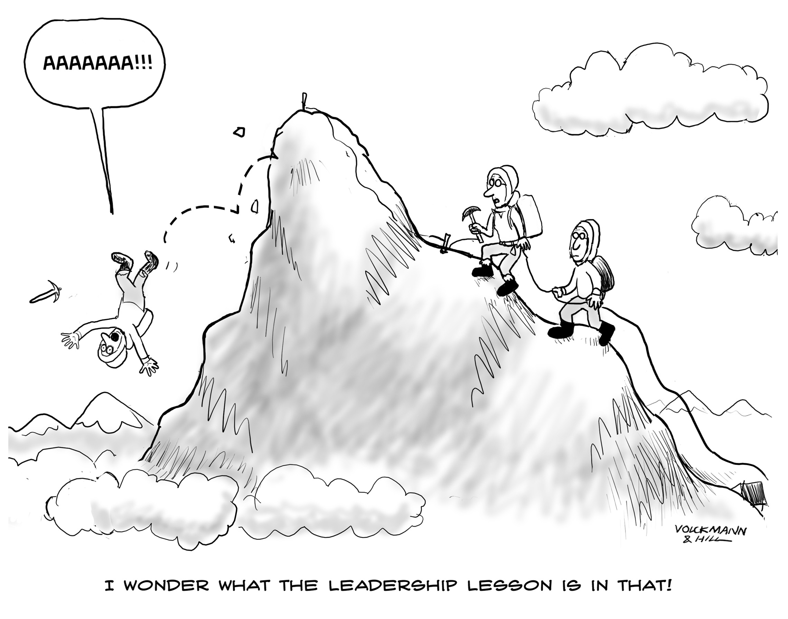
Nutrition  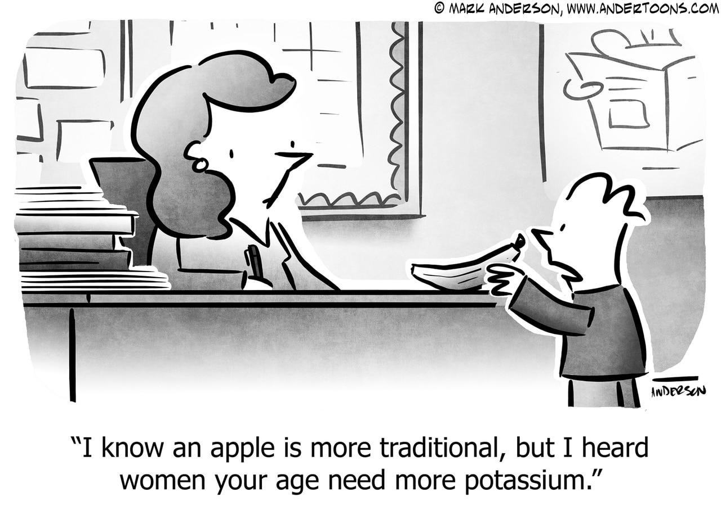 | Proposals  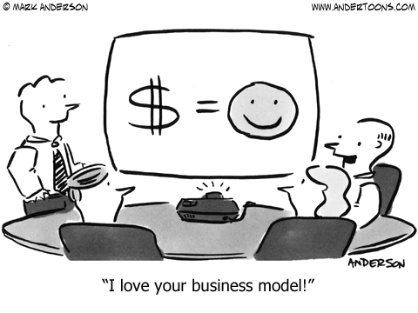
Environment | Customer Service  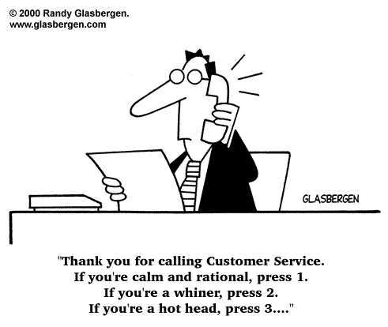
Motivation  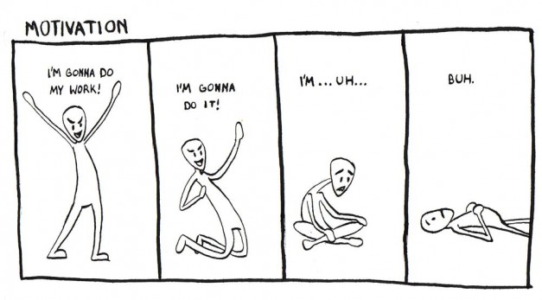 | Business Planning  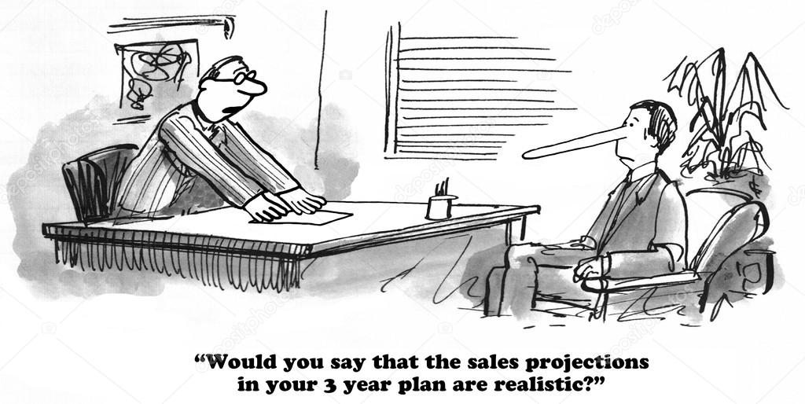
Business Coaching  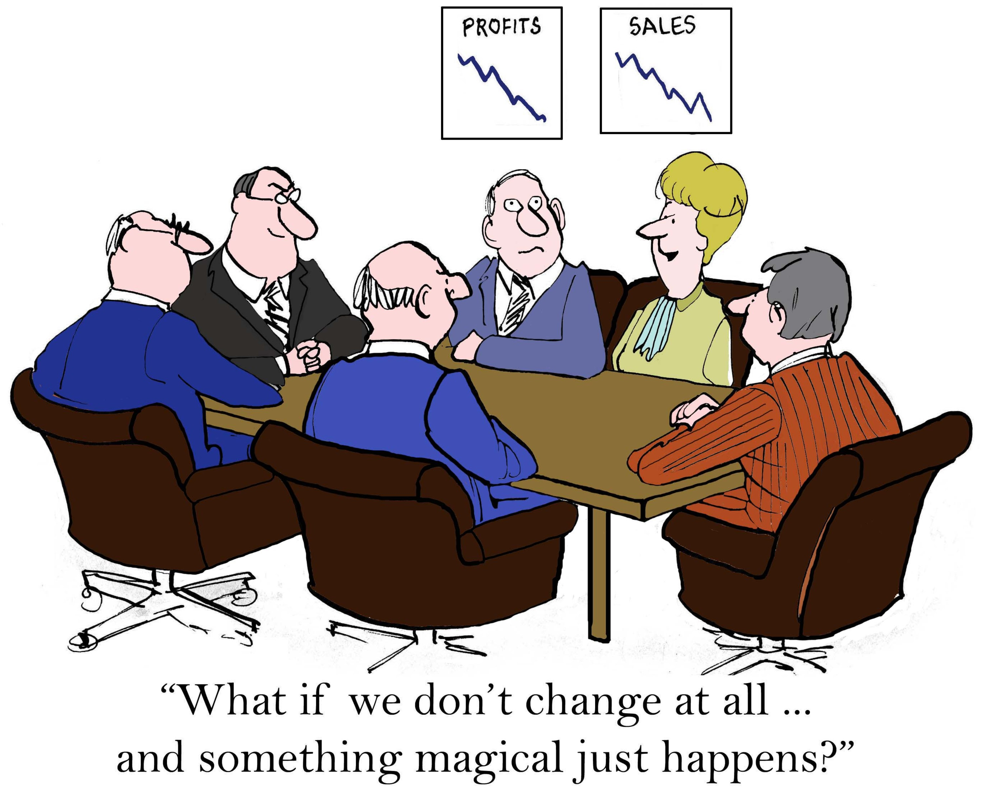 | Sales Training  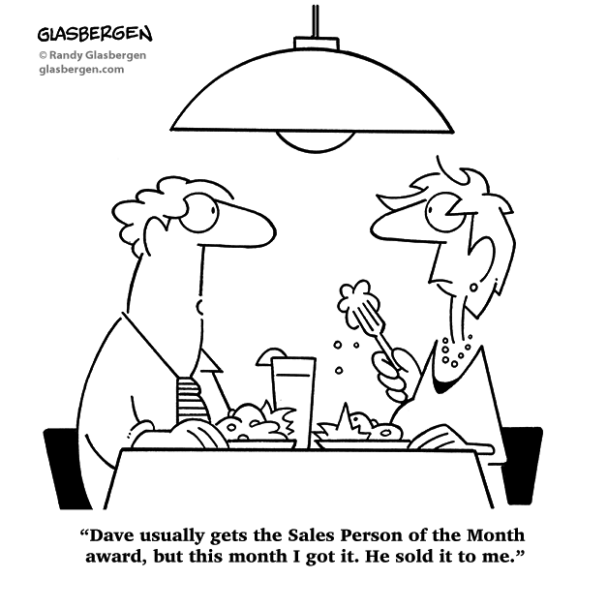

And now, see the outreach email below.

Dear Josephat,

We’ve all seen this opera a thousand times:
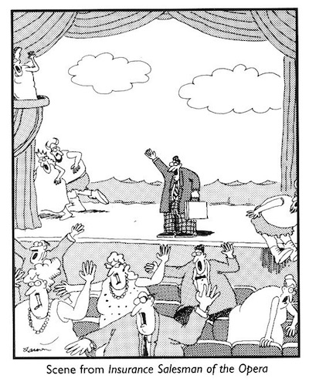

Yes, insurance sales people have been the victim of some pretty vicious stereotypes. And that just may be because they sometimes deserve it.

Hi, I’m Clifton Warren, and for the past several years I’ve been working to help insurance businesses and professionals change that image by marketing and selling themselves more professionally and effectively.

I give a talk/webinar on the topic that’s been very well received. Well, at least nobody threw tomatoes.

But seriously, I’ve spoken to many organizations such as NIBA, IBANZ, Suncorp, IAG, and Liberty Underwriting. All upstanding organizations.

Recently I did a presentation for Leader in Melbourne, and got this feedback:

“In five years of organising presentations, I have never seen an audience so eager not to miss a single point. Several people came up to me afterwards and said how much they appreciated having you as a speaker and that they felt a lot more confident now about marketing their business with the ideas you provided.”
Deborah McFarlane, Programs Director

If you're looking for a solid, yet entertaining program/webinar on how your members can more effectively market and sell their services, I would be happy to speak at your sales meeting, professional development day, or conference (I’m not picky).

If this interests you, excites you, or triggers immediate suspicion, can I at least send you details about my presentation with a long list of glowing testimonials to prove I’m the real deal?

Just reply to this email and I’ll dash it off to you immediately.

Then I’ll be in touch to answer any questions you may have, and promise to be somewhat entertaining in order give you a taste of what I’m like on stage.

Kind Regards,
Clifton Warren

